PLEASE JOIN US FOR THE INAUGURAL SUNDAY CE SEMINAR in SARASOTA.  MANASOTA OPTOMETRIC  SOCIETY |  | Manasota Optometric Society  Attn: Dr. David Rubin, OD  250 S. Tamiami Trail #103  Venice, FL 34285 |  |  | Manasota Optometric Society  Presents  - Super-sized Sunday CE Spectacular Seminar in Sarasota  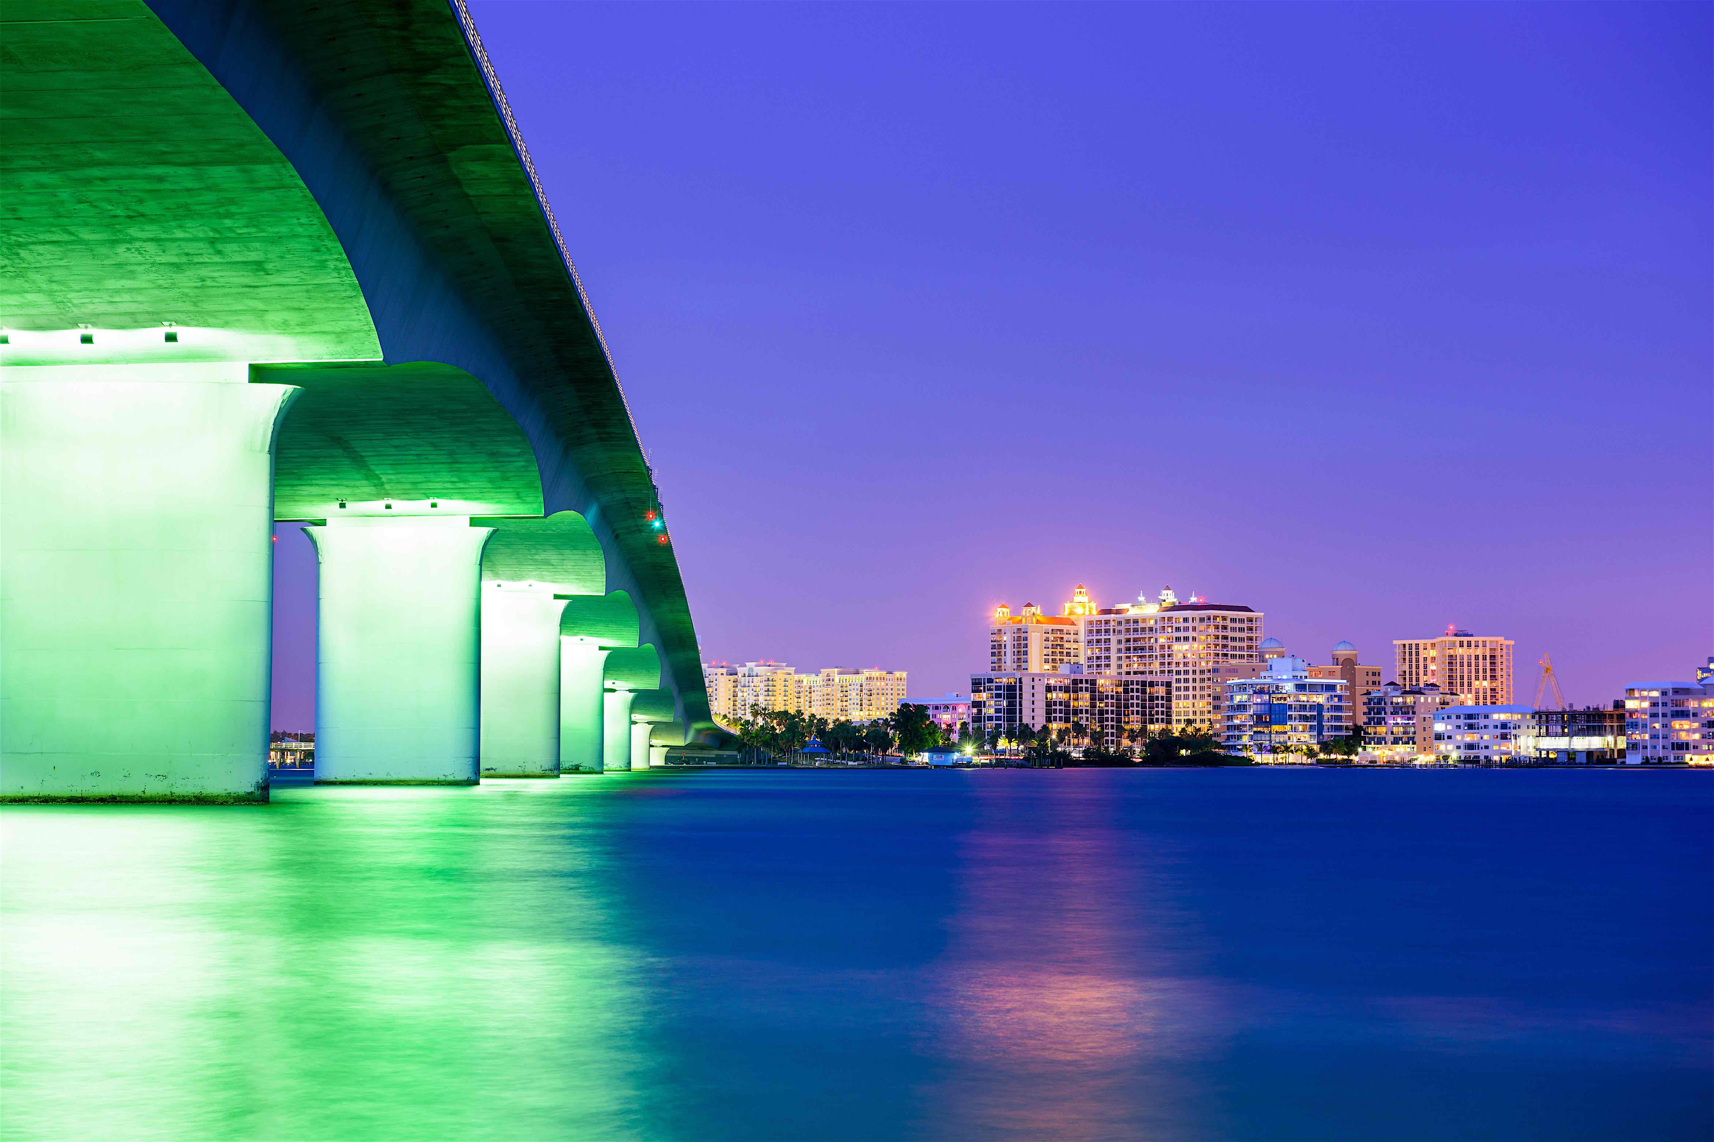  - September 15, 2019  8 hrs CE/4 hrs TQ  COPE approved courses

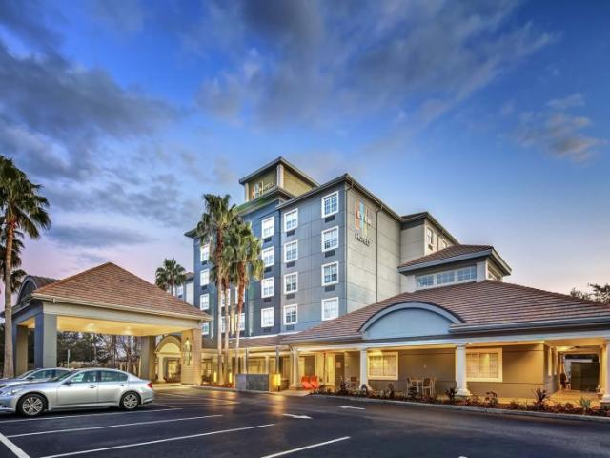  Even Hotel Sarasota  6231 Lake Osprey Drive  Sarasota, FL 34240 | Course Schedule  7:00 – 7:30 AM  Registration  7:20-7:50 AM  “Breakfast of Champions” sponsored by Maculogix  8 – 9:40 AM  Prevention of Medical Errors within Eyecare COPE ID: 59896-EJ  9:40 – 10 AM  “Coffee Talk” Break (sponsor TBD)  10 – 11:40 AM  Creating Distinction in Eye Care through Dry Eye, Allergy and Glaucoma Treatment and Protocols (TQ) COPE ID: 52395-AS  11:40 – 12:40 PM  “Lunch & Learn” (sponsor TBD)  12:40 – 2:20 PM  Best Practices in Ocular Emergencies (TQ) COPE ID: 52391-PD  2:20 – 2:40 PM  “Facts & Snacks” (sponsor TBD)  2:40 – 4:20 PM  Florida Jurisprudence Laws and Rules of Practice COPE ID: 27798-EJ | Registration  MOS Members - $100  FOA/AOA Members - $150  Non-Members - $200  If post-marked by August 15, 2019  After August 15, 2019  MOS Members - $125  FOA/AOA Members - $175  Non-Members - $250  Please include registration form.  Make checks payable to MOS.  Mail to:  Dr. David Rubin  Manasota Optometric Society  250 S. Tamiami Trail #103  Venice, FL 34285  Registration fee is non-refundable.  -----------------------------------------  Registration Form  Name:________________________OE#: _________ Lic#: __________  Registration Type: ______________  Address:______________________City:______________ State: _____  Zip:________  Tel: __________________________  Email: ________________________

